MOBLIE RECHARGE WEBSITE

by

Name of candidate(s):

Piyush kumar, Satyam deo, Shuvendu das

(section: K19CD)

(ROLL NUMBER(S): 43,44,42)



**Department of Intelligent Systems**

**School of Computer Science Engineering**

**Lovely Professional University, Jalandhar**

**APRIL-2020**

**Student Declaration**

This is to declare that this report has been written by us. No part of the report is copied from other sources. All information included from other sources have been duly acknowledged. We aver that if any part of the report is found to be copied, we are shall take full responsibility for it.

<< PIYUSH KUMAR>>

<<Roll number: 43>>

<<SATYAM DAS >>

<<Roll number: 44>>

<<SHUVENDU DAS>>

<<Roll number: 42>>

LOVELY PROFESSIONAL UNVERSITY

April 6, 2020

***BONAFIDE CERTIFICATE***

Certified that this project report “MOBLIE RECHAARGE WEBSITE ” is the bonafide work of “PIYUSH KUMAR , SATYAM DEO, SHUVENDU DAS” who carried out the project work under my supervision.

**Signature of supervisor**

***Name: Nikita Kaushik***

***UID. 25821***

Table of content

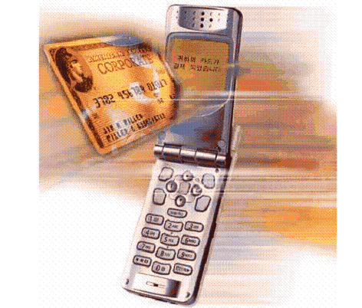

 Language Used

 Flow Chat

 Structure and Design

* Images of webpages

Conclusion

Language Required

1. Html (Hypertext markup language)
2. CSS 3(cascading style sheet)
3. JavaScript
4. Bootstrap 4

*Media used*

* Video
* Image
* Emoji’s
* Audio’s
* Gradient’s color

website purpose 

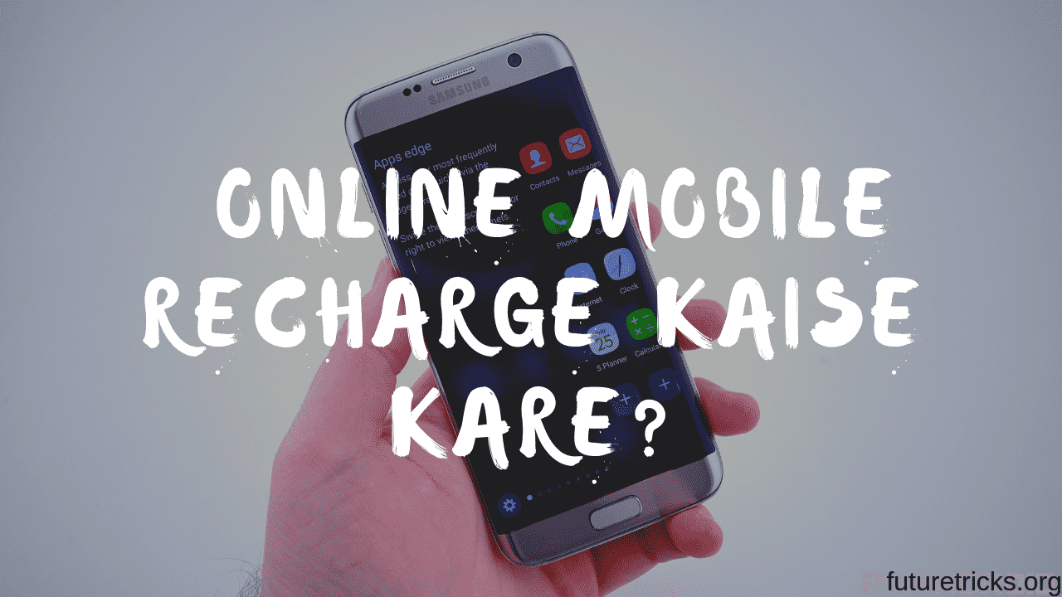

**In the current system the user who want to recharge their mobile have to go to any shop where recharge is available. They have to go the shop and ask for the specific recharge. The shopkeeper keeps the record of the number in any book.**

**This project is my effort for Online Mobile Recharge of mobile. This project useful for online recharging of mobile. This System provides recharge of many mobile companies as well as all kind of recharge are possible. This System will provide facility for customer to recharge mobile at anytime from anywhere. This System keeps the history of the past recharges. The user have to register himself.**

**Screen-shot of web page**

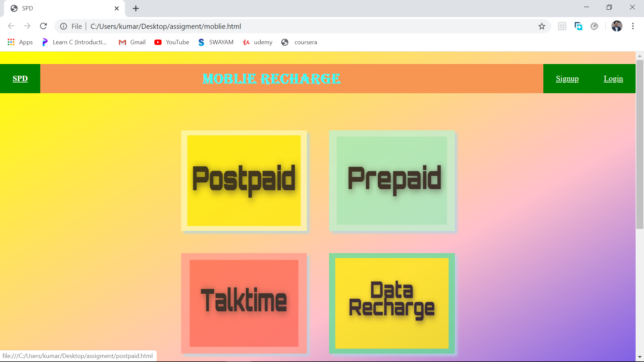 

This is the frist impression of our website .

In this we have used various of tag of html ,css ,javascript like <h1>,<p>,position,hover,img,and many more .

The background color is not a image we use the css tag (repeating-linear-gradient(-30deg,blue,pink,yellow))which make the make more attractive .And we also use <div>tag of css for dividing the body into three part and design it separately for more enhancement of web page.

Now get to our login and sign up pages

Sign up page(It is for both (admin & user ))

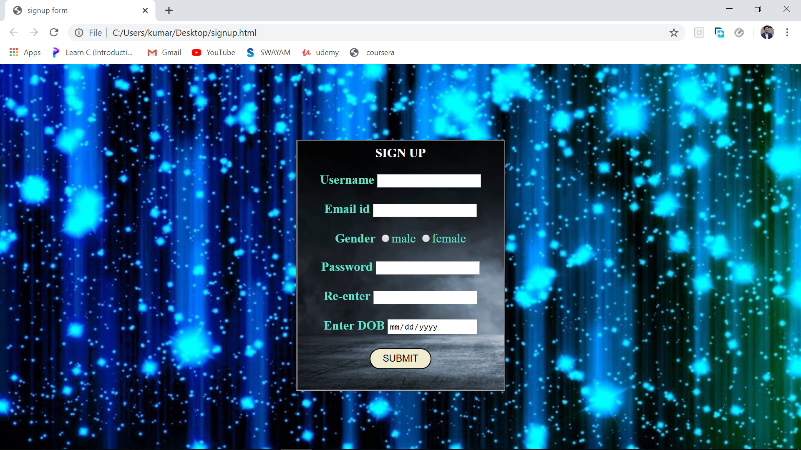

Login page(It is for both (admin & user ))

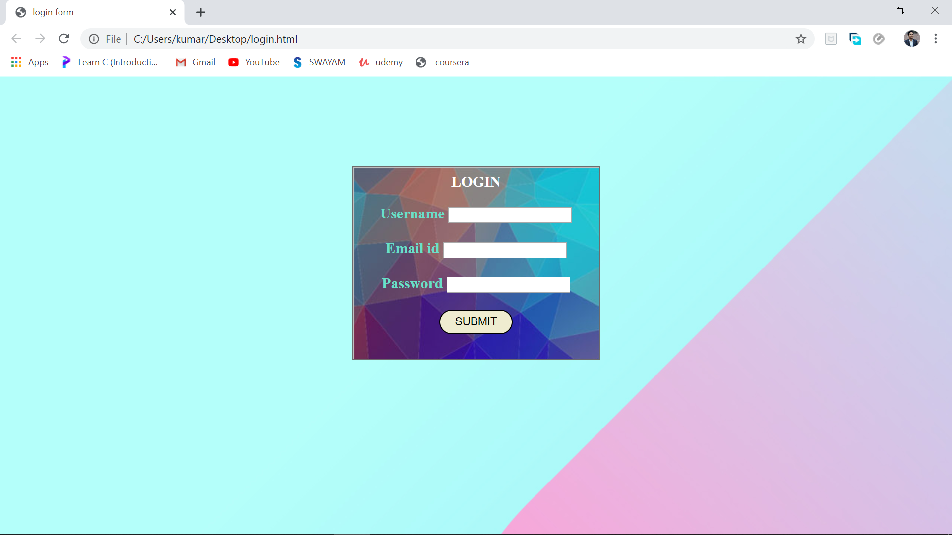

Lets go more in webpage and see its working

In this we have 4 option of recharge

* Postpaid

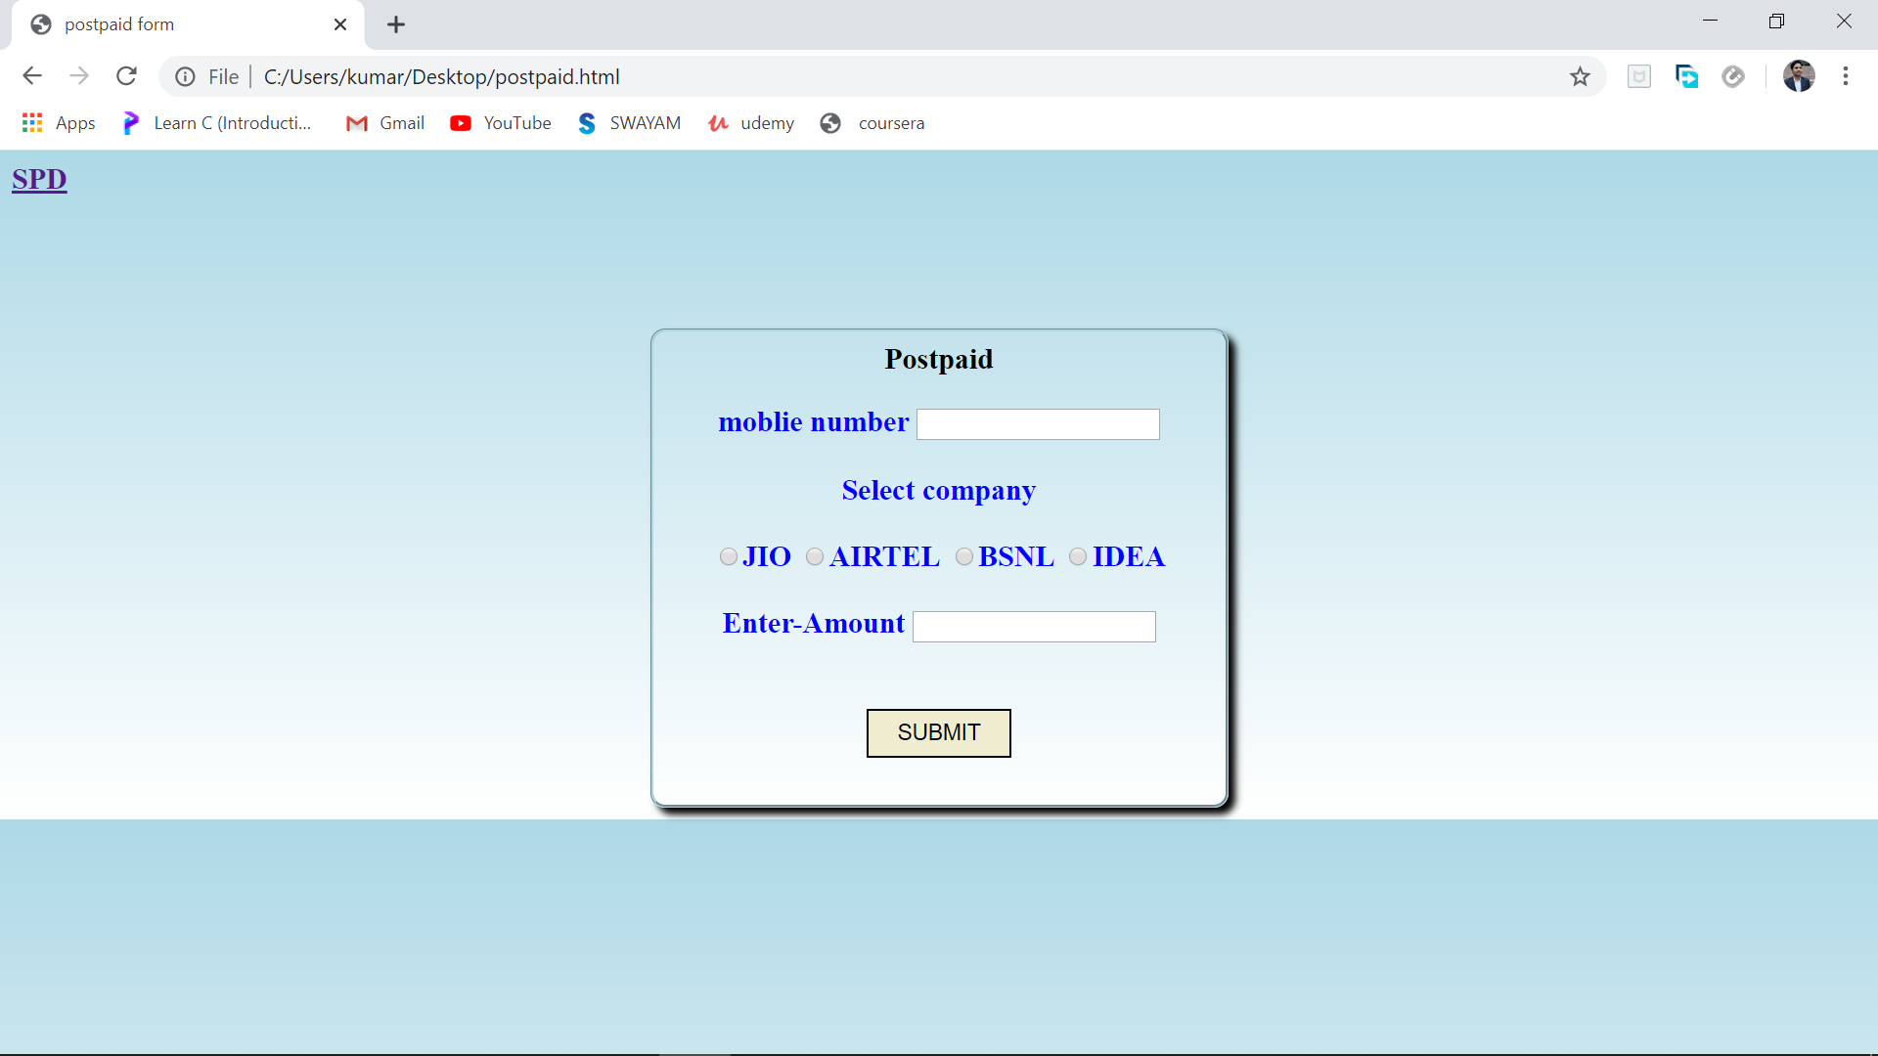

In this we use the html form with css for enhancement of website .

* Prepaid

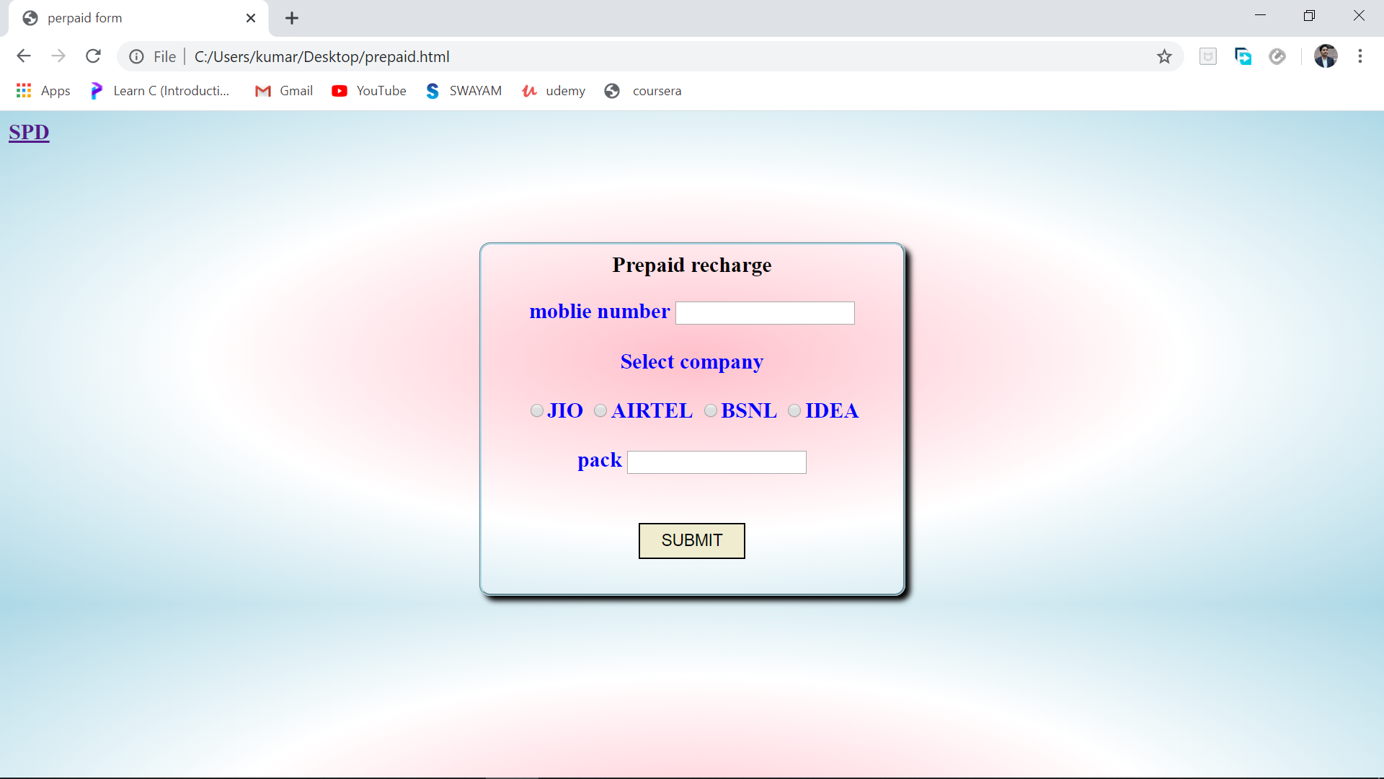

In this have the talktime recharge , data recharge column also to increase more user-friendly.

* Talktime

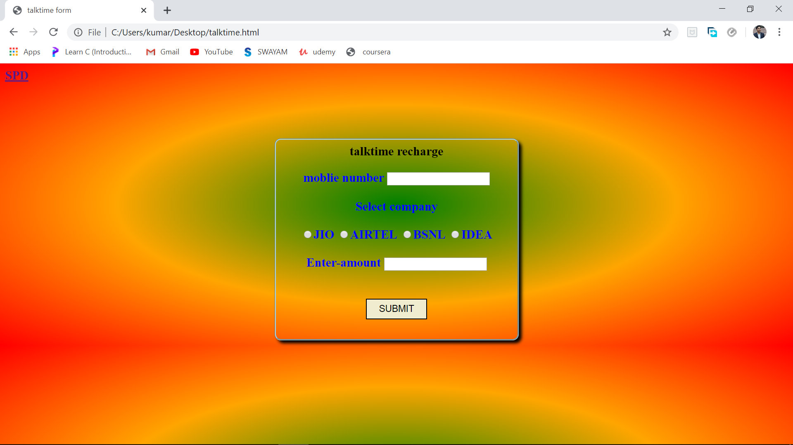

* Data recharge

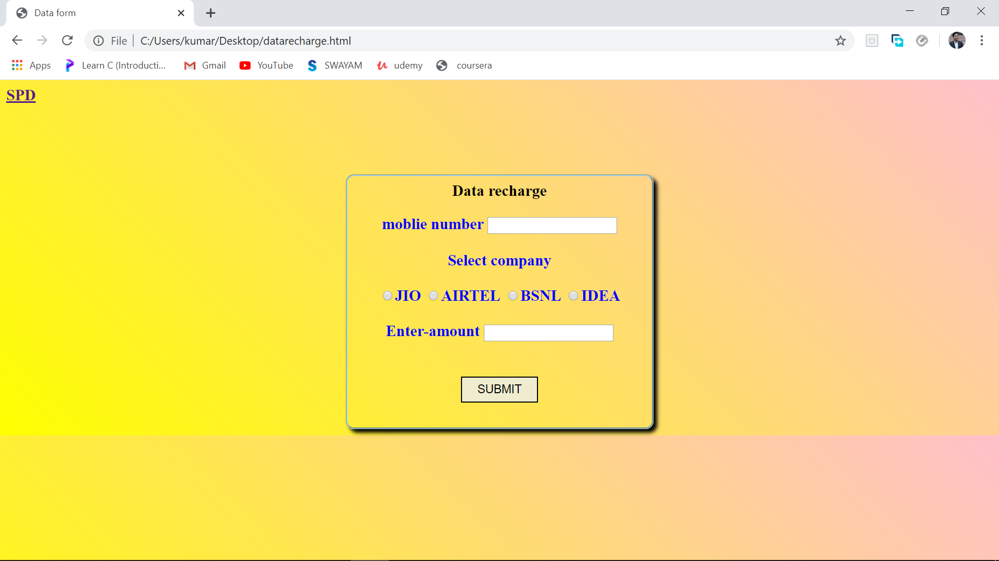

Submitted by:



Name:piyush kumar

Roll no.- 43

Name: satyam deo

Rollno.-44

Name: shuvendu das

Roll no.-42

Submitted to:

Name:Nikita kaushik

UID.-25821